**Technology Research**

2.2.1 **wearable sensors technology**

New technologies use vital sign monitoring systems. Such systems, developed for monitoring pregnancy include personal pregnancy health records [1], wearables [2], sensor systems [3], and the connectivity of devices through the IoT [4]. With the development of those technologies, wearable sensors networks are being rapidly developed. These sensor systems are accurate, portable, and can monitor vital signs in real time. They have been applied in multiple devices that can be integrated into the vital sign monitor system.

2.2.2 **Equipment and devices**

Polar H10 is a chest strap whose heart rate sensor can accurately monitor heart rate in real time. It has built-in memory to store data and uses Bluetooth to transfer data. It can be a part of integrated system.

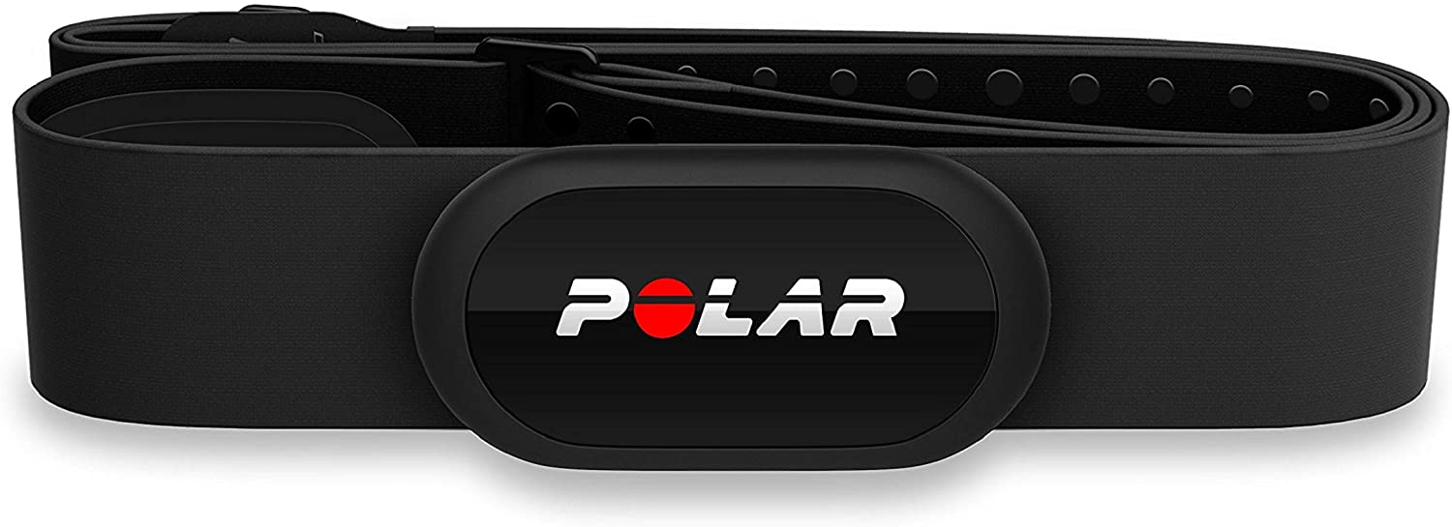

Figure.1 Polar H10

RENPHO Body Fat Scale is a smart scale to measure body weight, and transfer data using Bluetooth to get further analysis. It could be integrated system to gather the body weight.

Figure.2 RENPHO Body Fat Scale

**Market Research**

The aim of the application is to integrate multiple equipment and sensors to a system, collect and analysis various data, and generate health report. There are many health monitor applications like Apple, Xiaomi, and Huawei in the current market, which are not fully functional, but can be a good reference to our project.

**Reference:**

1. Smith MI, Garcia G, Simon M, Bruchanski L, Frangella J, Sommer JA, Giussi MV, Luna DR. Lessons Learned After Redesigning a Personal Health Record. InMEDINFO 2017: Precision Healthcare Through Informatics: Proceedings of the 16th World Congress on Medical and Health Informatics 2018 Jan 31 (Vol. 245, p. 216). IOS Press.
2. Piwek L, Ellis DA, Andrews S, Joinson A. The rise of consumer health wearables promises and barriers. PLoS Medicine. 2016 Feb 2;13(2):e1001953.
3. Tricoli A, Nasiri N, De S. Wearable and miniaturized sensor technologies for personalized and preventive medicine. Advanced Functional Materials. 2017 Apr;27(15):1605271.
4. Al-Fuqaha A, Guizani M, Mohammadi M, Aledhari M, Ayyash M. Internet of things: A survey on enabling technologies, protocols, and applications. IEEE Communications Surveys & Tutorials. 2015 Jun 15;17(4):2347-76.